BÁO CÁO THỰC HÀNH
IT3280 – 147793 – THỰC HÀNH KIẾN TRÚC MÁY TÍNH
Tuần 10:
Họ và tên | Lê Đồng Cảnh Phú
Mã số sinh viên | 20225755

Assignment 1

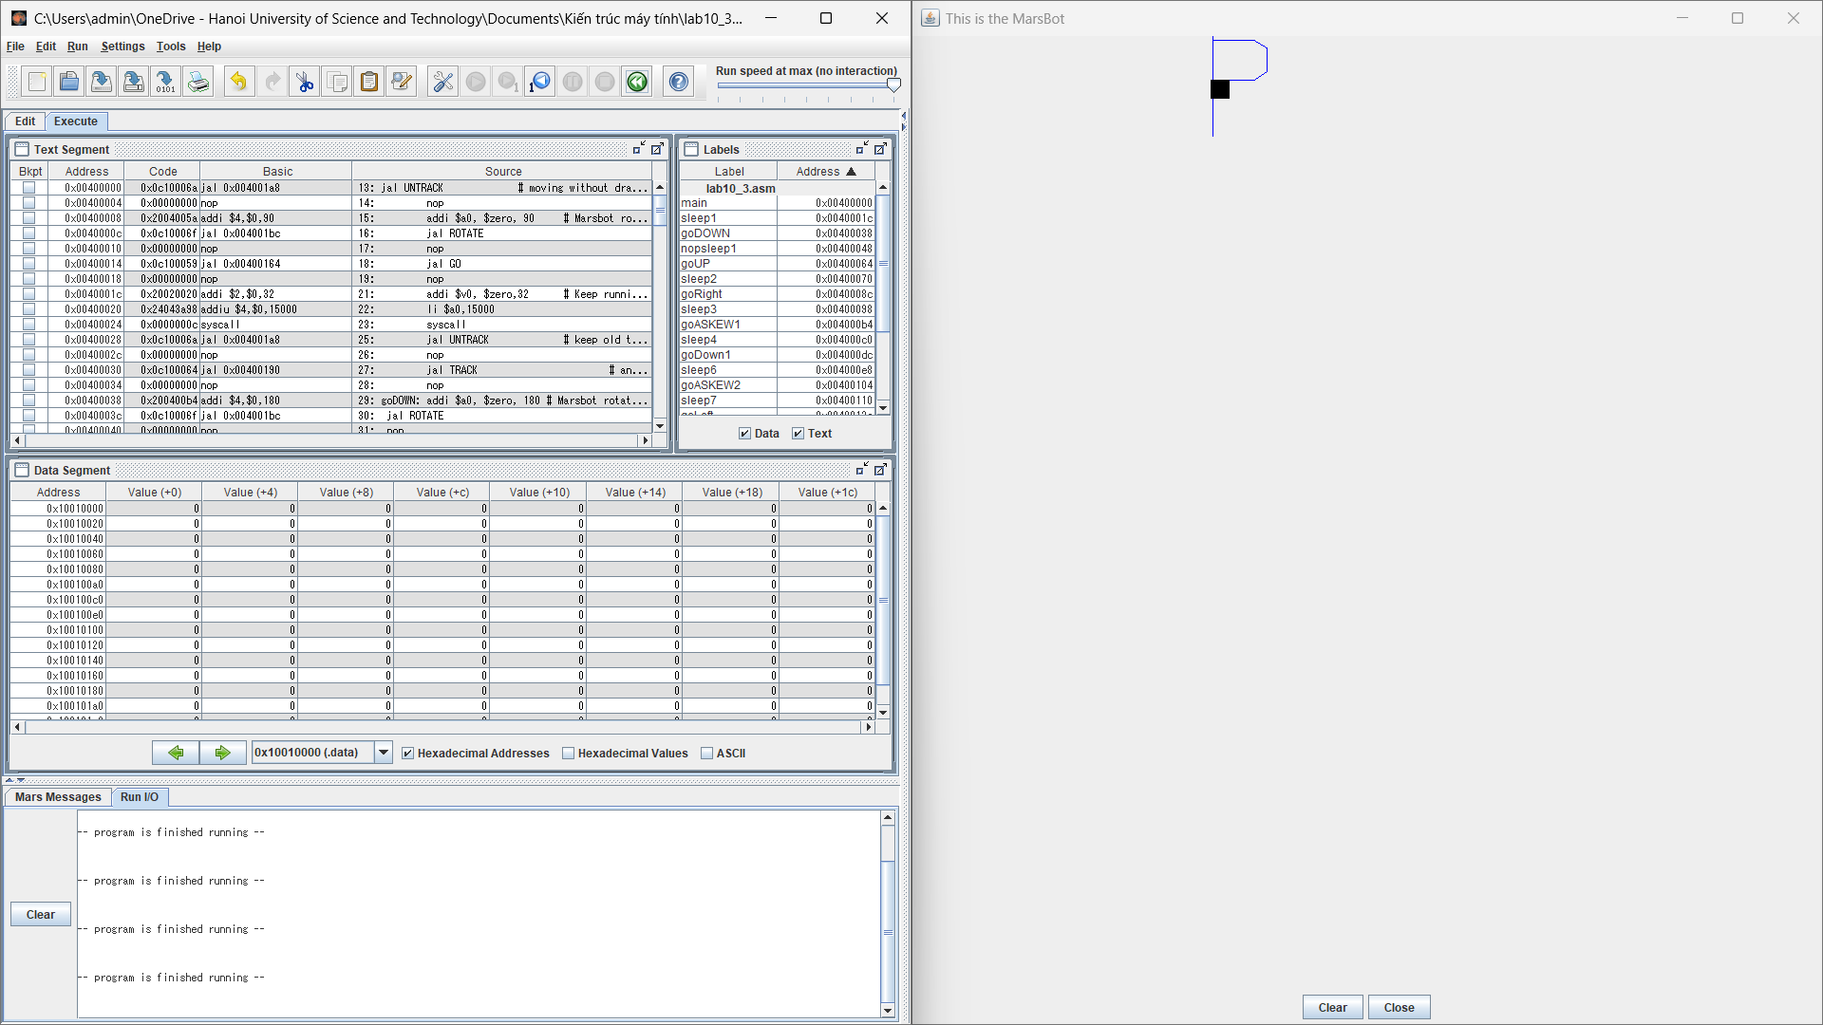
.eqv HEADING 0xffff8010 # Integer: An angle between 0 and 359
# 0 : North (up)
# 90: East (right)
# 180: South (down)
# 270: West (left)
.eqv MOVING 0xffff8050 # Boolean: whether or not to move
.eqv LEAVETRACK 0xffff8020 # Boolean (0 or non-0):
# whether or not to leave a track
.eqv WHEREX 0xffff8030 # Integer: Current x-location of MarsBot
.eqv WHEREY 0xffff8040 # Integer: Current y-location of MarsBot
.text
main:
jal UNTRACK # moving without drawing
nop
addi $a0, $zero, 90 # Marsbot rotates 90* and start running
jal ROTATE
nop
jal GO
nop
sleep1:
addi $v0, $zero,32 # Keep running by sleeping in 15000 ms
li $a0,15000
syscall

jal UNTRACK # keep old track
nop
jal TRACK # and draw new track line
nop
goDOWN: addi $a0, $zero, 180 # Marsbot rotates 180*
jal ROTATE
nop
jal GO
nopsleep1: addi $v0,$zero,32 # Keep running by sleeping in 5000 ms
li $a0,5000
syscall

jal UNTRACK # keep old track
nop
jal TRACK # and draw new track line
nop

goUP: addi $a0, $zero, 0 #Marsbot rotates 0*
jal ROTATE
nop
sleep2: addi $v0,$zero,32 # Keep running by sleeping in 4800 ms
li $a0,4800
syscall
jal UNTRACK # keep old track
nop
jal TRACK # and draw new track line
nop
goRight: addi $a0, $zero, 90 # Marsbot rotates 90*
jal ROTATE
nop
sleep3: addi $v0,$zero,32 # Keep running by sleeping in 2000 ms
li $a0,2000
syscall
jal UNTRACK # keep old track
nop
jal TRACK # and draw new track line
nop
goASKEW1:
addi $a0, $zero, 120
jal ROTATE
nop
sleep4: addi $v0,$zero,32 # Keep running by sleeping in 800 ms
li $a0, 800
syscall
jal UNTRACK # keep old track
nop
jal TRACK # and draw new track line
nop
goDown1:
addi $a0, $zero 180 #Marsbot rotates 180*
jal ROTATE
nop
sleep6: addi $v0, $zero, 32
li $a0, 1200
syscall
jal UNTRACK # keep old track
nop
jal TRACK # and draw new track line
nop
goASKEW2:
addi $a0, $zero, -120 #marbots rotates -120*
jal ROTATE
nop
sleep7: addi $v0, $zero, 32
li $a0, 800
syscall
jal UNTRACK # keep old track
nop
jal TRACK # and draw new track line
nop
goLeft: addi $a0, $zero, 270
jal ROTATE
nop
sleep5: addi $v0,$zero,32 # Keep running by sleeping in 2100 ms
li $a0,2100
syscall
jal UNTRACK # keep old track
nop
jal TRACK # and draw new track line
nop
end_main:
jal STOP
nop
li $v0, 10
syscall

#-----------------------------------------------------------
# GO procedure, to start running
# param[in] none
#-----------------------------------------------------------
GO: li $at, MOVING # change MOVING port
addi $k0, $zero,1 # to logic 1,
sb $k0, 0($at) # to start running
nop
jr $ra
nop
#-----------------------------------------------------------
# STOP procedure, to stop running
# param[in] none
#-----------------------------------------------------------
STOP: li $at, MOVING # change MOVING port to 0
sb $zero, 0($at) # to stop
nop
jr $ra
nop
#-----------------------------------------------------------
# TRACK procedure, to start drawing line
# param[in] none
#-----------------------------------------------------------
TRACK: li $at, LEAVETRACK # change LEAVETRACK port
addi $k0, $zero,1 # to logic 1,
sb $k0, 0($at) # to start tracking
nop
jr $ra
nop
#-----------------------------------------------------------
# UNTRACK procedure, to stop drawing line
# param[in] none
#-----------------------------------------------------------
UNTRACK:li $at, LEAVETRACK # change LEAVETRACK port to 0
sb $zero, 0($at) # to stop drawing tail
nop
jr $ra
nop
#-----------------------------------------------------------
# ROTATE procedure, to rotate the robot
# param[in] $a0, An angle between 0 and 359
# 0 : North (up)
# 90: East (right)
# 180: South (down)
# 270: West (left)
#-----------------------------------------------------------
ROTATE: li $at, HEADING # change HEADING port
sw $a0, 0($at) # to rotate robot
nop
jr $ra
nop

Assignment 2
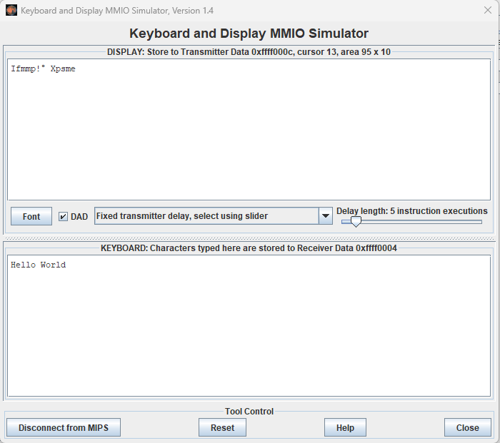
# Laboratory 10 Exercise 4
.eqv KEY_CODE 0xFFFF0004 # ASCII code from keyboard, 1 byte
.eqv KEY_READY 0xFFFF0000 # =1 if has a new keycode ?
# Auto clear after lw
.eqv DISPLAY_CODE 0xFFFF000C # ASCII code to show, 1 byte
.eqv DISPLAY_READY 0xFFFF0008 # =1 if the display has already to do
# Auto clear after sw
.text
li $k0, KEY_CODE
li $k1, KEY_READY

li $s0, DISPLAY_CODE
li $s1, DISPLAY_READY
loop: nop

WaitForKey:
lw $t1, 0($k1) # $t1 = [$k1] = KEY_READY
nop
beq $t1, $zero, WaitForKey # if $t1 == 0 then Polling
nop
#-----------------------------------------------------
ReadKey:
lw $t0, 0($k0) # $t0 = [$k0] = KEY_CODE
nop
#-----------------------------------------------------
WaitForDis:
lw $t2, 0($s1) # $t2 = [$s1] =DISPLAY_READY
nop
beq $t2, $zero, WaitForDis # if $t2 == 0 then Polling
nop
#-----------------------------------------------------
Encrypt:
addi $t0, $t0, 1 # change input key
#-----------------------------------------------------
ShowKey:
sw $t0, 0($s0) # show key
nop
#-----------------------------------------------------
j loop
nop

